**PROGRAM 5: AIRLINE FLIGHT DATABASE**

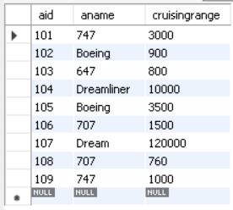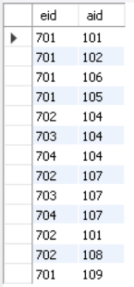

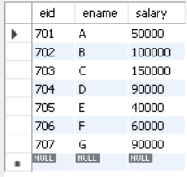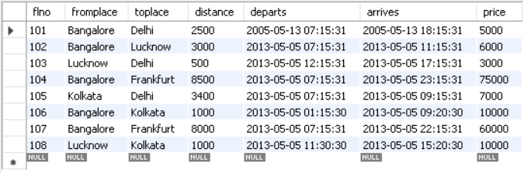

**QUERIES:**

1. Find the names of aircraft such that all pilots certified to operate them have salaries more than Rs.80,000.

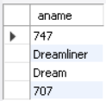

1. For each pilot who is certified for more than three aircrafts, find the eid and the maximum cruising range of the aircraft for which she or he is certified.

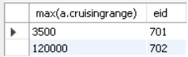

1. Find the names of pilots whose salary is less than the price of the cheapest route from Bengaluru to Frankfurt.

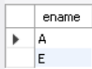

1. For all aircraft with cruising range over 1000 Kms, find the name of the aircraft and the average salary of all pilots certified for this aircraft.

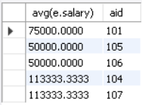

1. Find the names of pilots certified for some Boeing aircraft.



1. Find the aids of all aircraft that can be used on routes from Bengaluru to New Delhi.

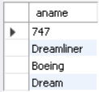

1. A customer wants to travel from Bangalore to Kolkata New with no more than two changes of flight. List the choice of departure times from Madison if the customer wants to arrive in Kolkata by 6 p.m.

